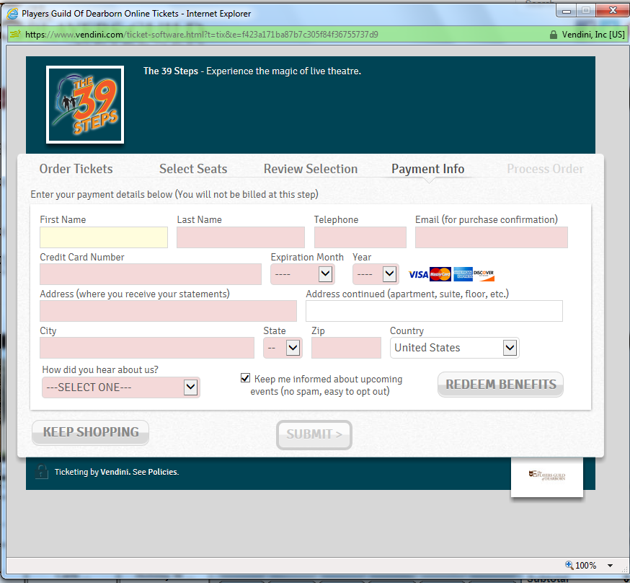
- Log onto our website www.playersguildofdearborn.org
- Click on the “Buy Tickets” button.
- You will be able to select your show, the date, and your seats. After you’ve done that click “Proceed to Payment.
- On the next screen (pictured) click “Redeem Benefits.”
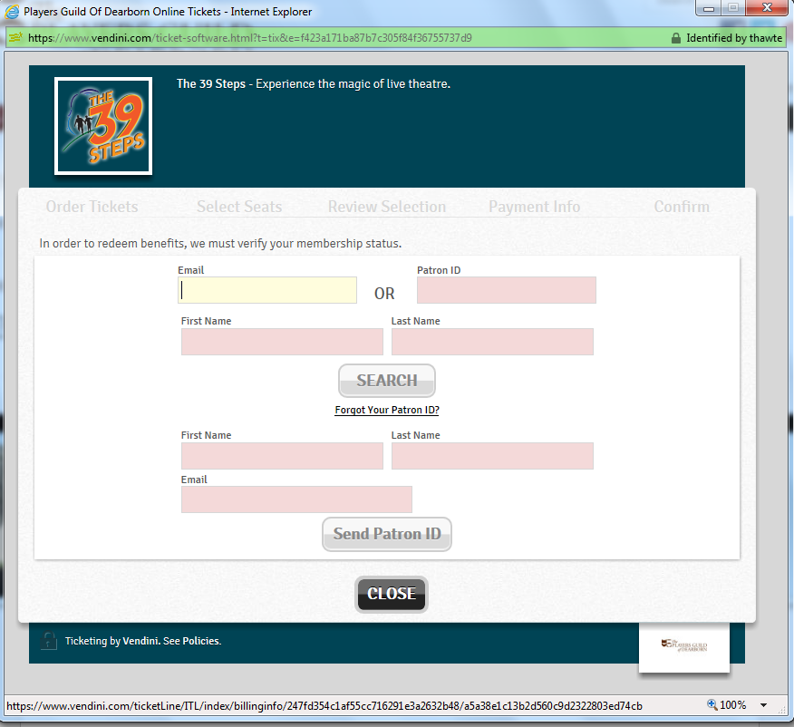
- We’ve set this up so that members can use their email address as their log in. On the next page members should enter their email address and first and last name. Members without an email address in their patron record will not be able to order online. Click “Search.”
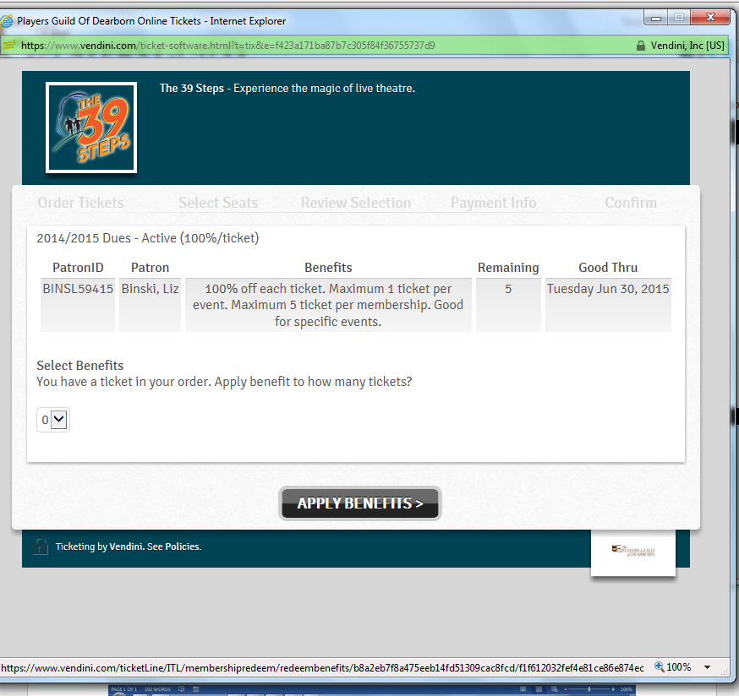
- Members will see the number of benefits they have available. Everyone will start the season with 5. As they redeem their tickets this number will dwindle. Members need to change the quantity from 0 to 1 and click “Apply Benefits.”

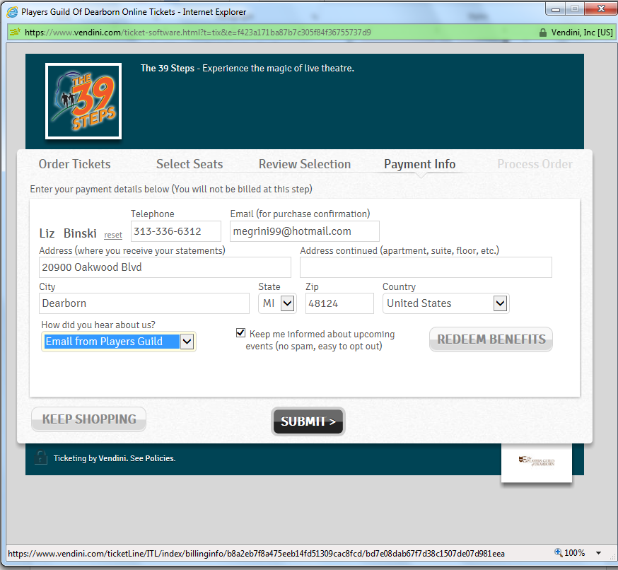
- They will be required to enter the information on the following page and then click “Submit.”
- To receive their tickets members will have to get to the “Process Order” page. This is located after the request for additional donations.
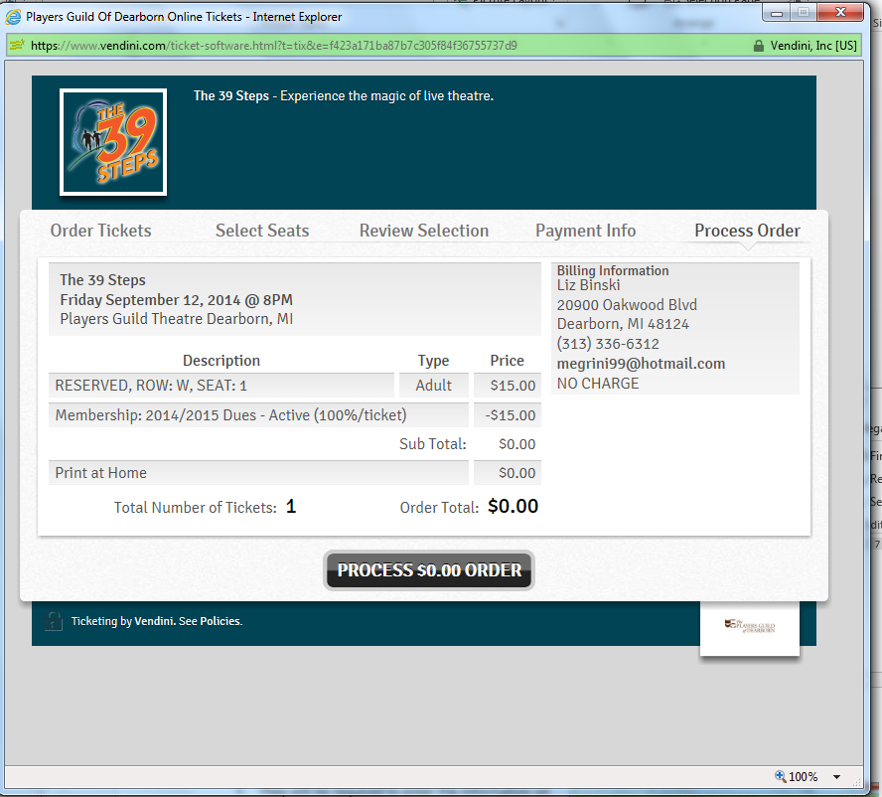
- Click “Process $0.00 Order” to complete the transaction.

