Go Back for Murder, Agatha Christie

Synopsis from Samuel French:
After receiving a letter from beyond the grave, Carla Crale believes her mother, who died in prison, was wrongly convicted of her father’s murder. In a passionate attempt to clear her name, she persuades those present on the day of her father’s death to return to the scene of the crime and ‘go back’ 15 years to recount their version of events.
An unusual take on the traditional murder mystery, the action of the play slips seamlessly from past to present, examining the danger of relying on personal testimony warped by time, prejudice and perception. By studying each suspect’s testimony, and the various inconsistencies between them, the drama arrives at a disturbing and terrible truth.
Characters:
Caroline Crale/Carla Le Marchant: Mother of Carla, wife of the victim/Daughter trying to clear her mother’s name.
Justin Fogg: The Lawyer trying to help Carla find peace.
Amyas Crale: The victim, an artist, murdered fifteen years ago.
Phillip Blake: The victim’s best friend, now a stockbroker.
Meredith Blake: Phillip’s younger brother, a recluse and former amateur herbalist.
Lady Melksham: A society lady, formerly Elsa Greer, the victim’s mistress.
Angela Warren: Caroline’s younger sister, now an archaeologist.
Miss Williams: Angela’s former governess, now retired.
Turnball: Justin Fogg’s assistant.
Jeff: Carla Le Marchant’s husband to be.
Set Design:
The first Act takes place in various locations. While trying to clear her mother’s name and uncover the truth, Carla acts as her mother 15 years prior. Here she visits the offices of Justin Fogg and Phillip Blake, a hotel suite, Miss William’s apartment, and an Asian restaurant. Act two takes place in a house in Western England.
Set Dressing/Props:
All the places in Act 1 in flashbacks would be taken place in 1930’s. The home in act 2 is set “present day” which is 1950’s.

Costumes:
Costumes has a fun challenge in transforming Carla from herself in 1950’s to be a young version of her mother in the 1930’s. Since it’s played by the same person, this will be a fun way to show the difference in these two characters.

Why We Chose It:
We strongly felt that it’s been enough time since we did our last Mystery play. We also feel that a mystery is something that our audience’s love. We also felt that this would be a welcomed challenge to both our actors, and our crew; a time to be creative with sets, and costumes in order to show the difference between present time and past. We also thought that there was a lot of meat to this script that would captivate our audience.

https://www.youtube.com/watch?v=i1mx9xS5MTY
This Youtube clip is a review of a community theater’s production. It shows nice ideas of what the show is all about, and what it should look like.

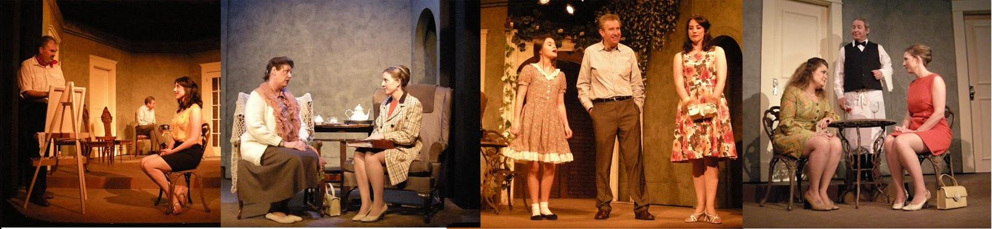
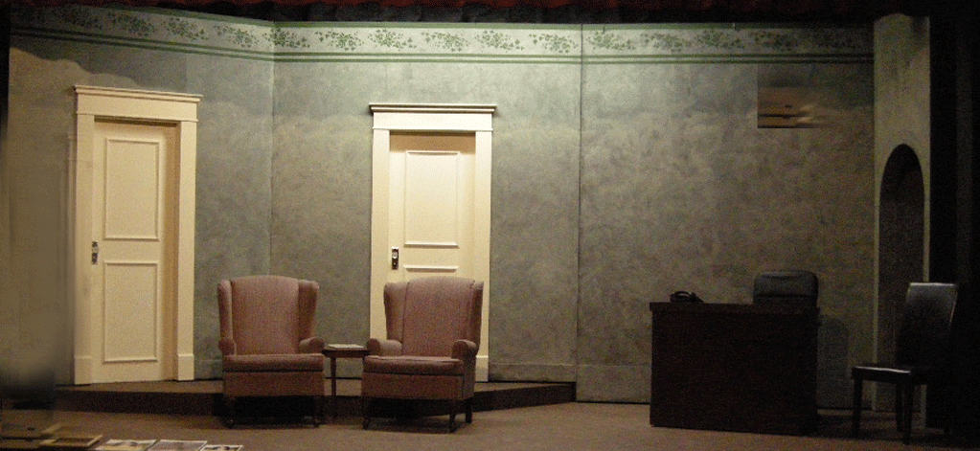
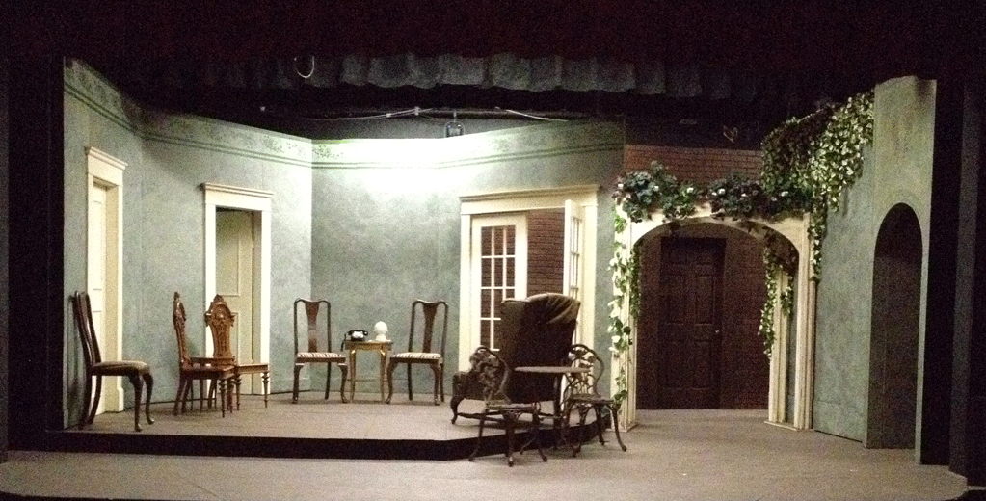
This theater put the set on hinges so that in Act 1 it could be a flat set in order to change settings and places. Then in Act 2 they added the ivy and décor to make it the house.
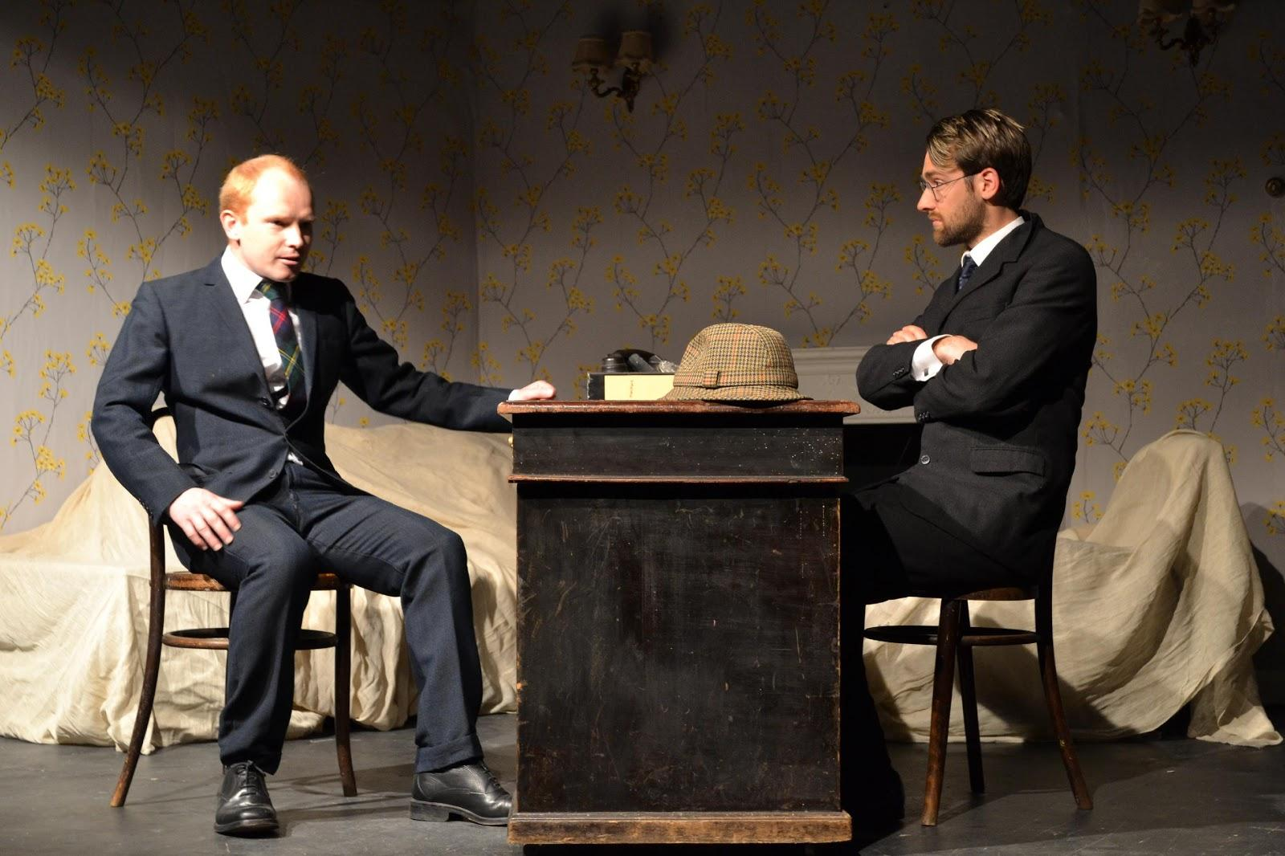
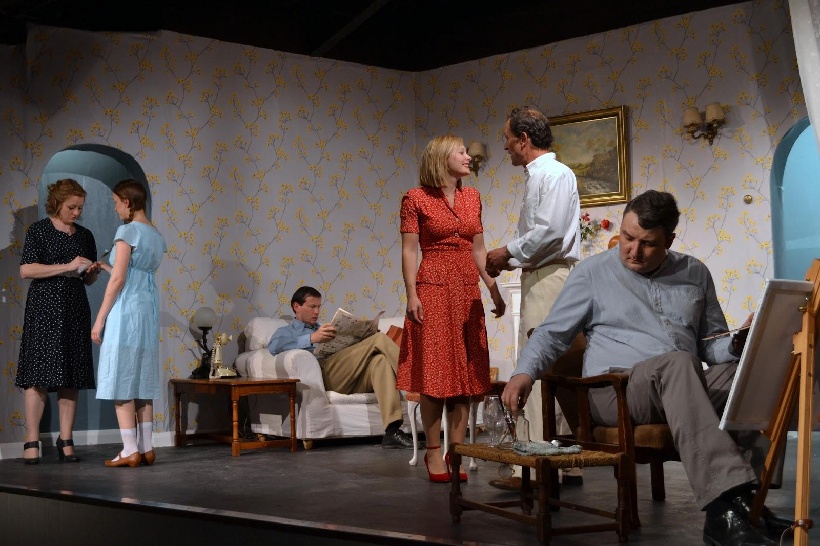
This theater simply covered the set in Act 1 with sheets and then uncovered for the housing.
Guys and Dolls
Music by Frank Loesser Book by Abe Burrows and Jo Swerling

Considered by many to be the perfect musical comedy, Guys and Dolls ran for 1,200 performances when it opened on Broadway in 1950. It received nearly unanimous positive reviews from critics and won a bevy of awards, including Tony Awards, Drama Desks and Oliviers. Frequently revived, the show has been done with numerous all-star casts, including productions/concerts featuring Ewan McGregor, Jane Krakowski, Brian Stokes Mitchell and Jessica Biel.
Set in Damon Runyon's mythical New York City, Guys and Dolls is an oddball romantic comedy. Gambler, Nathan Detroit, tries to find the cash to set up the biggest craps game in town while the authorities breathe down his neck; meanwhile, his girlfriend and nightclub performer, Adelaide, laments that they've been engaged for fourteen years. Nathan turns to fellow gambler, Sky Masterson, for the dough, and Sky ends up chasing the straight-laced missionary, Sarah Brown, as a result. Guys and Dolls takes us from the heart of Times Square to the cafes of Havana, Cuba, and even into the sewers of New York City, but eventually everyone ends up right where they belong.
Frank Loesser's brassy, immortal score makes Guys and Dolls a crowd pleaser. The large cast features both a variety of ensemble and star roles. With a great collection of production resources from MTI, this highly producible show is a treat for audiences and performers of any age.

Cast Size: Flexible
Cast Type: Ensemble Cast
Dance Requirements: Standard

Character Breakdown
Nicely-nicely Johnson
Just like his name suggests, he is the nicest and cheeriest of the gambling crooks. High-spirited and a bit naïve, but sincere and genuine. Nathan's loyal friend and lackey.
Gender: Male
Age: 30 to 45
Vocal range top: B5
Vocal range bottom: D4
Benny Southstreet
Nathan's right-hand man and a gambler himself. Smart, slick, always moving and shaking, but with what he thinks are Nathan's best interest at heart.
Gender: Male
Age: 30 to 45
Vocal range top: G5
Vocal range bottom: D4
Sarah Brown
A pretty, bright-eyed woman who serves as Sergeant of the local Mission. She fully believes in her worthy cause and wishes to convert the gambling sinners to saints. Falls unexpectedly in love with Sky along the way. She is prudish and uptight, but eventually lets go.
Gender: Female
Age: 20 to 30
Vocal range top: G5
Vocal range bottom: B3
Arvide Abernathy
The bass drum and cymbal player in the Mission band, he is Sarah's loving grandfather. Wise and sweet, he wants nothing but the best for her.
Gender: Male
Age: 50 to 65
Vocal range top: F5
Vocal range bottom: D4
Harry The Horse
A crook and gambler. He is a tough guy with dollar signs as his bottom line. Brings Big Jule into Nathan's craps game and backs his cheating, but is also a man of his word in the gambling community.
Gender: Male
Age: 35 to 55
Vocal range top: G5
Vocal range bottom: F3
Lt. Brannigan
A New York police officer who is on to Nathan's illegal craps games and is dead-set on catching him. A tough, no-nonsense character.
Gender: Male
Age: 40 to 55
Nathan Detroit
A good-hearted gambler and craps game organizer who could never hit the bigtime. He loves Adelaide, but cannot quit his gambling ways. A broke schemer with unwitting ways.
Gender: Male
Age: 35 to 45
Vocal range top: F5
Vocal range bottom: D4
Miss Adelaide
Nathan's fiancé and a lead performer at the Hot Box nightclub. She loves Nathan more than anything in the world and desperately wants to get married. Pretty, outspoken, stubborn.
Gender: Female
Age: 25 to 35
Vocal range top: E5
Vocal range bottom: A3
Sky Masterson
A high-stakes gambler whose luck never seems to run out, and a wild card who surprises himself when he falls in love with the unlikeliest of women. Suave, smart, handsome.
Gender: Male
Age: 35 to 45
Vocal range top: E5
Vocal range bottom: B3
Big Jule
A big time craps player from Chicago who uses a gun and his own pair of rigged dice to bully his way into never losing. Tough looking. A bit of an oaf.
Gender: Male
Age: 30 to 50
Vocal range top: G5
Vocal range bottom: F3
Ensemble: Sightseers, Mission Band (Agatha, Calvin, Martha), Crap Shooters (Liver Lips Louie, Angie The Ox, Rusty Charlie), Hot Box Girls, Waiters, Cuban Dancers

Awards
1951 Tony Award Best Musical Won
Best Performance by a Leading Actor in a Musical Robert Alda Won
Best Performance by a Featured Actress in a Musical Isabel Bigley Won
Best Choreography Michael Kidd Won
Best Direction of a Musical George S. Kaufman Won

Set Design
Flexible and modular to represent New York City interiors (nightclub, Salvation Army) Havana and other street scenes

Lighting
Nothing out of the ordinary

Costumes
The time period is 1930’s, will need uniforms for Salvation Army, costumes for Adelaide and Hot Box Dancers and Suits for the gangsters.

Properties
Sample prop list
https://sites.google.com/site/psuguysanddolls/props-list

Lend Me A Tenor by Ken Ludwig

Synopsis
Lend Me A Tenor is set in September 1934. Saunders, the general manager of the Cleveland Grand Opera Company, is primed to welcome world famous, Tito Morelli, Il Stupendo, the greatest tenor of his generation, to appear for one night only as Othello. The star arrives late and, through a hilarious series of mishaps, is given a double dose of tranquilizers and passes out. His pulse is so low that Saunders and his assistant Max believe he’s dead. In a frantic attempt to salvage the evening, Saunders persuades Max to get into Morelli's Othello costume and makeup and fool the audience into thinking he's Il Stupendo. Max succeeds admirably, but Morelli comes to and gets into his other costume ready to perform. Now two Othellos are running around in identical costumes and makeup and two women are running around in lingerie, each thinking she is with Il Stupendo. This is a madcap, screwball comedy, complete with mistaken identities and slamming doors, guaranteed to leave audiences teary-eyed with laughter.

Characters
Saunders – 50-ish; Lead- General Manager of the Cleveland Grand Opera Company
Max – 30-ish; Lead - Saunders' long-suffering assistant
Maggie – 20-something; Lead - Saunders' daughter, and Max's girlfriend
Tito Morelli – 40-something; Lead - The world's most renowned opera tenor, and notorious ladies man
Maria – 40-ish; Supporting - Tito's long-suffering wife, with an "Italian temper"
Diana – Ageless; Supporting - The opera's ingenue soprano, who is "flinging her way" to the top
Julia – 50-60s; Featured - Chairwoman of the Cleveland Opera Guild
Bellhop – 20-something; Featured - An obnoxious opera fan who has an ongoing feud with Saunders

Awards
Tony Award for Best Actor
Tony Award for Best Director
Drama Desk Award for Best Actor
Drama Desk Award for Best Featured Actress
Drama Desk Award for Best Director

Set Design
The play takes place in 1934, in a hotel suite in Cleveland, Ohio. The two-room set has a sitting room with a sofa and chairs stage right and a bedroom stage left. A center "stage wall" divides the two rooms, with a door leading from one room to the other. Throughout the play the audience can see what's happening in both rooms at the same time.

Set Dressing/ Props/ Costumes
The set design, set dressing, and props need to reflect an upscale hotel suite in 1934 Cleveland, Ohio. 1930s period clothing; two identical Othello costume
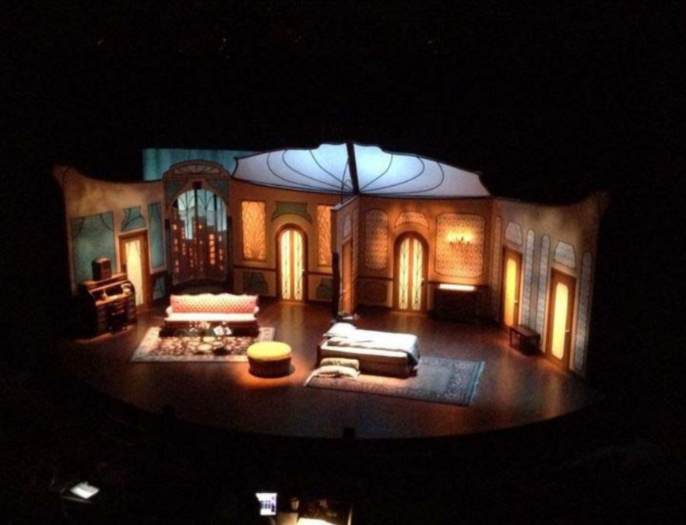
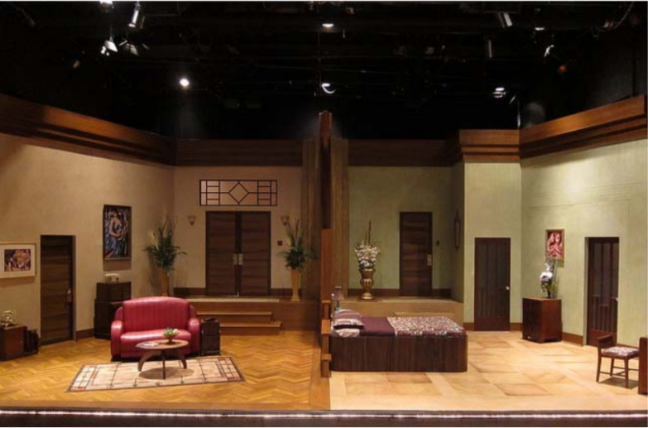

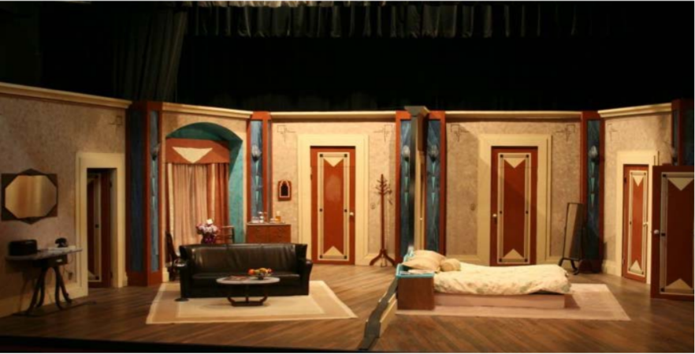

Peter and the Starcatcher By Rick Elice
based on the novel Peter and the Starcatchers by Dave Barry and Ridley Pearson

An ensemble of actors enters a bare stage and addresses the audience. With a bit of bickering, they welcome us to the world of the play and tell us what’s in store: flying, dreaming, adventure and growing up. Before our eyes, they begin to tell the story behind a story we know so well: A young orphan and his mates are shipped off from Victorian England to a distant island ruled by the evil King Zarboff. They know nothing of the mysterious trunk in the captain’s cabin, which contains a precious, otherworldly cargo. At sea, the boys are discovered by a precocious young girl named Molly, a Starcatcher-in-training who realizes that the trunk’s precious cargo is starstuff, a celestial substance so powerful that it must never fall into the wrong hands. When the ship is taken over by pirates — led by the fearsome Black Stache, a villain determined to claim the trunk and its treasure for his own — the journey quickly turns into a thrilling adventure. And, before our eyes, one miserable orphan comes to be The Boy Who Would Not Grow Up — the one and only Peter Pan.

From marauding pirates and jungle tyrants to unwilling comrades and unlikely heroes, Peter and the Starcatcher playfully explores the depths of greed and despair … and the bonds of friendship, duty and love.

Winner of 4 Tony Awards, Drama Desk Award

Requirements
This is a play with music. A vocal/music director and accompanist will be necessary. The show is in two acts.

Cast Size: 11 Men, 1 Woman
All actors play multiple characters (nearly 100 in all) and narrators throughout the show, including:
Black State, a notorious pirate
Molly Aster, a precocious young girl and Starcatcher-in-training
The Boy (Peter), nameless, homeless and friendless
Grempkin, a nasty schoolmaster
Mrs. Bumbrake, Molly’s nanny (played by a man)
Bill Slank, the captain of the ship The Neverland
Smee, Black Stache’s first mate
Prentiss, an ambitious young orphan
Alf, an old sailor
Lord Leonard Aster, Molly’s father and loyal subject to the Queen
Captain Robert Falcon Scott, captain of The Wasp
Ted, an orphan obsessed with food
King Prawn, leader of the Mollusks
A host of sailors, pirates, orphans, mermaids, and Mollusks (island natives)

Set Design
The set is hodgepodge of pieces, nothing totally complete. It is as if the actors pull items out of trunks (boxes, ropes, fabric, chairs, etc.) and use them to create everything from an English port to the deck of a ship to the beach of a fantastic island.

Lighting
Lights will play an important part in the show, as there are scenes divided between two different areas at the same time, in addition to the time of day, a stormy sea, a jungle island, and more.

Costumes
The time period is mid- to late 1800s. While some costumes are specific (ship’s captain, ranking naval officials, etc.), most are a rag-tag collection of well-worn items. These are players who know they are doing something theatrical — there is a coordinated make-shift nature to what they wear. Specialty items include the mermaid costumes in the second act (see YouTube sample).

Properties
Set and props blend together a bit for this show, in terms of boxes, trunks and rope, all of which must be sturdy and/or pliable. Two small model ships are needed. Pennants and flashlights may be needed to construct the Crocodile (see sample image below). An edible pineapple is required for each show.

Production Samples:

https://www.youtube.com/watch?v=OZj5yj8SDBA

https://www.youtube.com/watch?v=glFA8MMCEPA

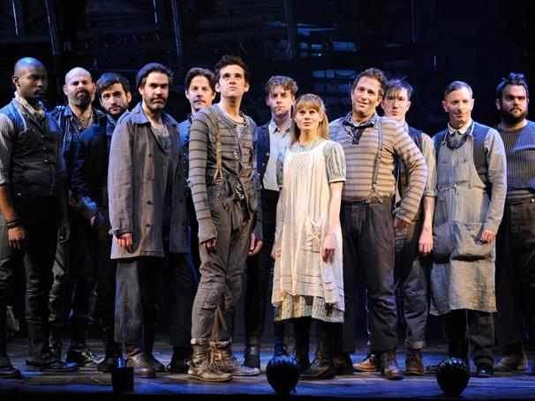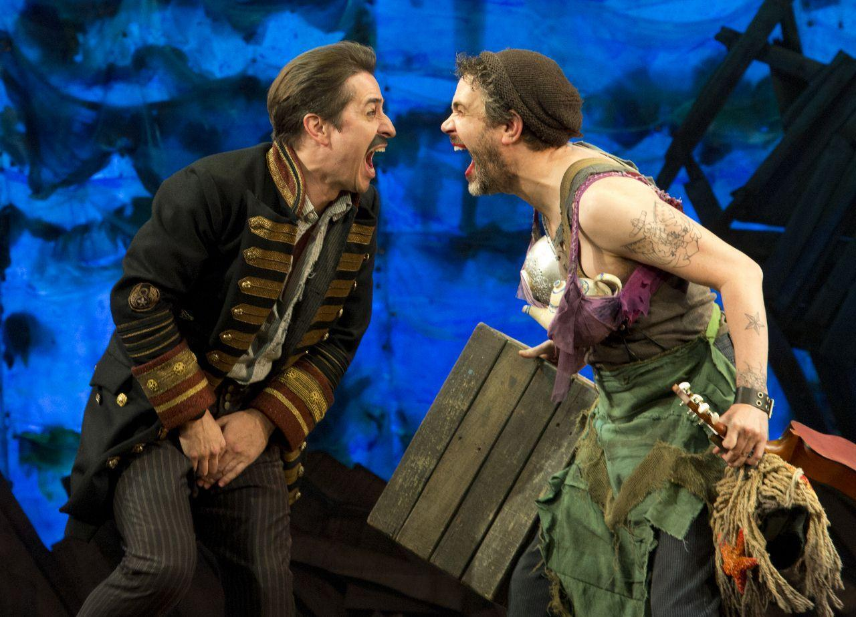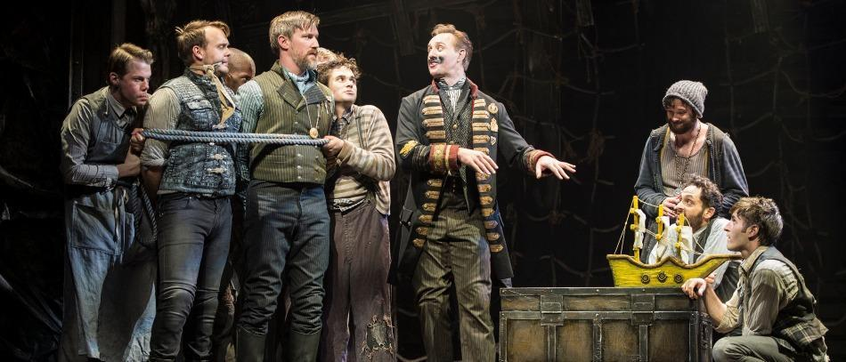

It Shoulda Been You—Book and Lyrics by Brian Hargrove, Music by Barbara Anselmi

The bride is Jewish. The groom is Catholic. Her mother is a force of nature. His mother is a tempest in a cocktail shaker. And, when the bride's ex-boyfriend crashes the party, the perfect wedding starts to unravel faster than you can whistle "Here Comes the Bride!" It's up to the sister of the bride to turn a tangled mess into happily ever after in this musical comedy for anyone who ever had parents.
It Shoulda Been You is an excellent choice for the Guild—it is a new musical with strong roles for a really varied range of women. There is no choreography needed for the show, save for a few moments with the groom and his father. The characters are also written to be ethnically diverse, which is beneficial in trying to widen the casting pool for the Guild. Overall it’s incredibly silly, fun, and heartwarming, and hopefully audiences will leave with a smile on their faces.
Cast
Albert  Wedding planner.  Gender: Male  Age: 45 to 55 | Judy Steinberg  Mother of the bride.  Gender: Female  Age: 55 to 65
Annie Sheps  African-American, co-maid of honor.  Gender: Female  Age: 25 to 30 | Marty Kaufman  Bride's ex-boyfriend.  Gender: Male  Age: 30 to 35
Brian Howard  Groom.  Gender: Male  Age: 25 to 30 | Mimsy/aunt Sheila  Waiter & bride's aunt.  Gender: Female  Age: 45 to 55
George Howard  Father of the groom.  Gender: Male  Age: 50 to 65 | Murray Steinberg  Father of the bride.  Gender: Male  Age: 55 to 65
Georgette Howard  Mother of the groom.  Gender: Female  Age: 50 to 65 | Rebecca Steinberg  The bride.  Gender: Female  Age: 25 to 30
Greg Madison
Best man.
Gender: Male
Age: 25 to 30
Jenny Steinberg  Co-maid of honor and bride's older sister.  Gender: Female  Age: 30 to 35 | Walt/uncle Morty  Waiter & bride's uncle.  Gender: Male  Age: 45 to 55

Set
The show takes place in present day, inside a New York hotel. It is preferable to have two stories, and the feel is a hotel ballroom; throughout the show different pieces are pulled in and out to represent different rooms within the hotel.
Costumes
Modern day wedding wear—bridesmaid and wedding dresses, suit/tuxedos, etc. There is one scene with all of the women in the show getting ready, so there may be a need for robes in that particular scene. The supporting cast is also in business/formal wear.
Props
Good amount of bar/glassware for multiple scenes. Otherwise quite light on props.
Lights/Sound
Minimal. You should be able to hear “the wedding” going on through different doors within the hotel.

